JOINS
Sample records in Department, Faculty, and Student tables:
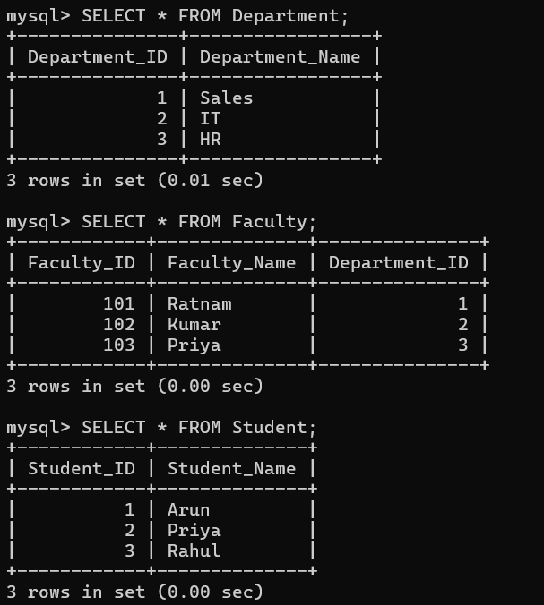
Sample records in Course, Score, and Teaches tables:
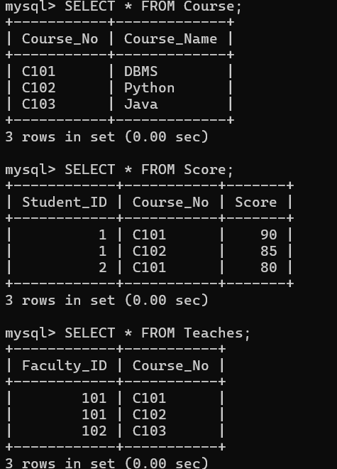


List the departments where the faculty members are working
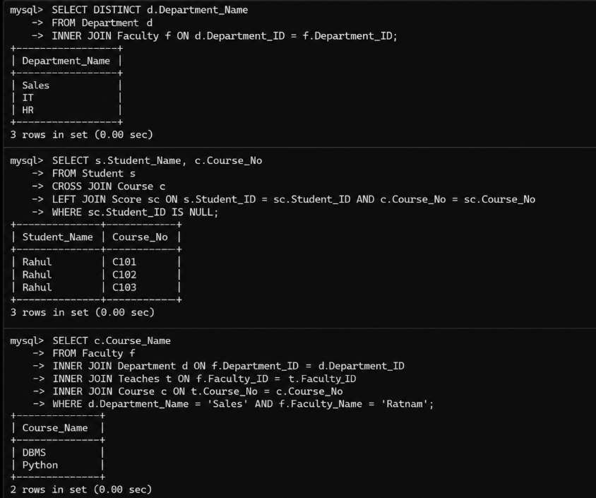
Find the student who has no score in any of the courses. List the student name and course number.

The office clerk needs the names of the courses taken by the faculty belonging to the 'Sales' department whose name is 'Ratnam'


